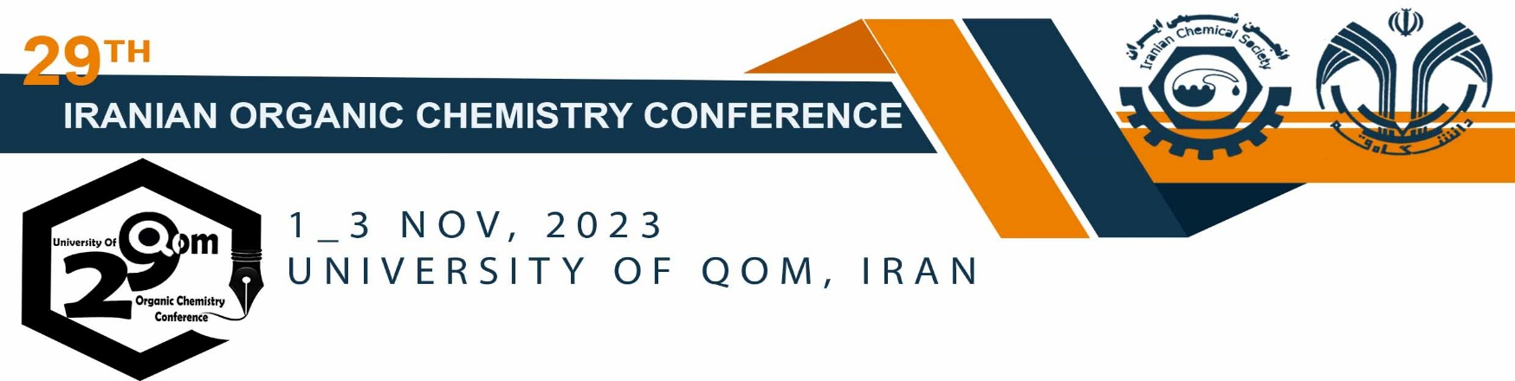

Title (Times New Roman 13 Bold) (max. 15 words),

Author1^{a*}, Author2^{b} and Author3ª (Times New Roman 11 bold)

- Organic Chemistry Laboratory, Faculty of Chemistry, University of Qom, Qom, Iran, email of corresponding author (Times New Roman 11 Regular)
- Polymer Research Laboratory, Faculty of Chemistry, University of Tehran, Tehran, Iran, email of presenter

Keywords: (Times New Roman 11 Bold) (Max. 5 keywords) “Keyword 1”, “Keyword 2”, “Keyword 3” (Times New Roman 11 Regular)

Use Times New Roman 12 Regular for the main text. Use Times New Roman 12 Regular for the main text. Use Times New Roman 12 Regular for the main text. Use Times New Roman 12 Regular for the main text [1]. Use Times New Roman 12 Regular for the main text [2]. Use Times New Roman 12 Regular for the main text. Use Times New Roman 12 Regular for the main text. Use Times New Roman 12 Regular for the main text. Use Times New Roman 12 Regular for the main text (Scheme).

Scheme: Use Times New Roman 11 to explain your scheme.

References (Times New Roman 11 Bold) (Max 4 Refs)
- (Times New Roman 11 Regular), follow ACS Style Guide for referencing, ACS Style example is available in the next reference.
- Zolfigol, M. A.; Yarie, M.; Baghery, S. Application of {[4,4′-BPyH][C(CN)3]2} as a bifunctional nanostructured molten salt catalyst for the preparation of 2-amino-4H-chromene derivatives under solvent-free and benign conditions. Synlett 2016, 27, 1418−1422.

